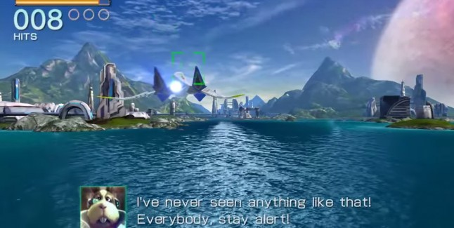

Level Design Document:

Ride the Shark

Half Life 2 – Valve Software (Renan)

Version 1.0

|  |  |
| --- | --- |
| Designer: | Renan Henrique Pereira de Lima |
| Document Date: | 09/08/2015 |
| Intended Level Delivery Date: | 10/06/2015 |

**Document Revisions Table**

|  |  |  |  |
| --- | --- | --- | --- |
| **Version** | **Description** | **Requestor** | **Date** |
| 0.5 | Renan (Quick Summary done) | Professor | 09/08/2015 |
| 0.75 | Renan (Level Summary, Level Details (partially) done) | Professor | 09/08/2015 |
| 0.95 | Renan (Level Details (completely), Critical Asset List, Appendix done) | Professor | 09/08/2015 |
| 1.0 | Initial (Complete) Document | Professor | 09/08/2015 |
|  |  |  |  |
|  |  |  |  |
|  |  |  |  |
|  |  |  |  |
|  |  |  |  |
|  |  |  |  |
|  |  |  |  |
|  |  |  |  |
|  |  |  |  |
|  |  |  |  |
|  |  |  |  |
|  |  |  |  |
|  |  |  |  |
|  |  |  |  |
|  |  |  |  |
|  |  |  |  |
|  |  |  |  |
|  |  |  |  |
|  |  |  |  |

# Table of Contents

Table of Contents 3

Table of Figures 5

Quick Summary 7

Hook(s) 7

Gameplay Highlights 7

Setting Summary 7

Mission Difficulty 8

Mission Metrics 8

Characters 8

Visual Themes 9

Key Theme References 9

Level Summary 10

Campaign 10

Context 10

Backstory 10

Aftermath 10

Objective(s) 10

Overview Map 11

Level Flow 11

Flow Summary 11

Level Progression Chart 12

Level Details 13

Gameplay Area Breakdown Map 13

Obstacle Types 14

Detailed Walkthrough 15

Area 0: Research Facility 15

Initial Loadout 15

Gameplay/Story 15

Text and Dialog 15

Visual References 16

Perspective Shots 19

Area 1: Warm Up 20

Gameplay/Story 20

Text and Dialog 21

Visual References 21

Environment References 22

Perspective Shots 23

Area 2: Battle in the Mountains 24

Gameplay/Story 24

Text and Dialog 25

Visual References 25

Area 3: The Final Impulse 27

Gameplay/Story 27

Text and Dialog 28

Visual References 28

Critical Asset List 29

Appendix 30

Why is this fun? 30

What makes this sequence interesting/memorable? 30

How will you communicate to the player what they need to know? 30

How can the player break it? 30

References 31

# Table of Figures

Figure 1: Concept art for a secret research lab [26] 9

Figure 2: In-game example of research hideout [25] 9

Figure 3: Countryside example (*Half-Life 2: Episode 2* screenshot) [27] 9

Figure 4: Mountains and Pinewood forest reference [28] 9

Figure 5: Overview Map (enemies not displayed for better map visualization) 11

Figure 6: Level Progression Chart 12

Figure 7: Area Breakdown Map (enemies not represented) 13

Figure 8: Obstacle 1 – Tower 14

Figure 9: Obstacle 2 – Cliff 14

Figure 10: Obstacle 3 – Bridge 14

Figure 11: Obstacle 4 – Tunnel 14

Figure 12: Area 0 Detail Map with Keys 15

Figure 13: Main Character Example (Gordon Freeman) [1] 16

Figure 14: Dr. Kleiner [5] 16

Figure 15: Another example of ship used as reference for the Space-shark [4] 17

Figure 16: Example of Shark-shaped ship (reference for the Space-shark vehicle) [3] 17

Figure 17: Old sci-fi lab (architecture and lighting examples) [6] 18

Figure 18: Example of Black Mesa’s hideout – reference for models, architecture and mood [2] 18

Figure 19: Texture example for old sci-fi setting [7] 19

Figure 20: In-game reference for Black-Mesa research facilities (models and lighting) [8] 19

Figure 21: Area 1 Detail Map with Keys 20

Figure 22: Reference for the type-1 enemy (turrets similar to the striders) [9] 21

Figure 23: In-game reference for setting, texture and models – riverbed [10] 22

Figure 24: In-game reference for setting, texture and models – canyons and mountains [11] 22

Figure 25: Reference for riverbed along the mountains [13] 22

Figure 26: In-game reference for models - train track/rails [12] 22

Figure 27: Another example of cliff [15] 22

Figure 28: Cliff example (game obstacle) [14] 22

Figure 29: Example of rock tower (obstacle) [16] 23

Figure 30: Lighting reference (sunset) [17] 23

Figure 31: Area 2 Detail Map with Keys 24

Figure 32: Reference for the enemy introduced by the area, type 2 (dynamic/flying) [18] 25

Figure 33: Another reference for the tunnel (different approach: train tracks) [20] 25

Figure 34: Architecture/shape reference for the tunnel [19] 25

Figure 35: Sunset example for lighting and colors [21] 26

Figure 36: Similar color palette for sunset lighting [22] 26

Figure 37: Area 3 Detail Map with Keys 27

Figure 38: Moutain tunnel example [23] 28

Figure 39: Another reference for the tunnel [24] 28

Level Abstract

# Quick Summary

“Ride the Shark” is a new level available in the expansion pack for the sci-fi game Half-Life 2 (PC, Xbox, Xbox 360, Playstation 3, Mac OS and Linux). It tells a side story, providing a different gameplay from the traditional Half-Life series. In this single-player level, players experience a 3D flying shooter, controlling Gordon Freeman on board of the airship recently created by Black Mesa: Space-shark. In “Ride the Shark”, players must use the flying vehicle to defend one of Black Mesa’s research facilities, fighting against Combine units and avoiding obstacles such as cliffs and bridges. The level takes place during the timeframe of Half-Life 2: Episode 2, following its setting (countryside, mountains, pinewood forest).

## Hook(s)

This level provides several hooks:

* Protecting Black Mesa’s research facilities and mountain surroundings
* Flying on the airship: Space-shark

## Gameplay Highlights

“Ride the Shark” includes:

* Flying shooter (3rd person-perspective gameplay when onboard of the airship)
  + Player controls the airship vertically and horizontally, while it is always moving forward
    - However, there are boundaries that prevent the airship from escaping the level/flying over everything
  + Player has two different weapons at disposal (available in the airship):
    - Submachine gun – player shoots quickly (low delay between shots); ammo recharges over time
    - Missiles (rockets) – player shoots slowly (high delay between shots); ammo also recharges over time, but takes longer.
* Players have infinite number of lives but restart the level from the beginning if they die, which might happen when they:
  + Run out of health (when shot by enemies)
  + Collide with an obstacle, or enemy (instant death)

## Setting Summary

|  |  |
| --- | --- |
| **Theme** | Sci-fi Research Laboratory, Alien and Sky-high (flying among the mountains) |
| **Mood** | Excitement, Thrilling, Empowerment |
| **Setting** | During Half-Life 2: Episode 2, Eastern European countryside (Mountains, Pinewood Forest, Mining) |
| **Time of Day** | Sunset time (around 6pm) |
| **Season** | Spring |
| **Weather** | Sunny – anything but rain/snow |

## 

## Mission Difficulty

|  |  |  |
| --- | --- | --- |
| Position | Difficulty | Reasons |
| Beginning | 3 | Tutorial part of the level, it might be a little difficult due to the different kind of gameplay |
| Middle | 5 | Waves with more enemies and different types of them, combined with more challenging obstacles |
| End | 8 | Ramping up the difficulty, the end has much more enemies and obstacles, demanding more player skill |

Scale: 1-10 (1 is Easiest and 10 is Hardest)

## Mission Metrics

|  |  |
| --- | --- |
| **Play Time** | 8 minutes |
| **Critical Path** | 11520 hammer units = 219.456m  (players revisit the same area several times) |
| **Physical Area** | WXH = 2048 x 3072 hammer units = 39 x 58 m |

### Characters

|  |  |
| --- | --- |
| Character | Description |
| Gordon Freeman (Player’s character) | Half-Life series’ main character, Gordon Freeman is a scientist at the Black Mesa Research Facility, who has been fighting against the Combine and other consequences from his actions since the first game. In this level, he is helping scientists in the development process of a flying vehicle when the combines suddenly attack their research hideout. |
| Dr. Kleiner  (NPC, Ally) | Gordon Freeman’s former Professor at MIT, Dr. Isaac Kleiner is one of the Black Mesa’s survivor scientists. In this mission, along with Freeman, he is building the Space-shark flying vehicle. He instructs players about the airship and gives the player a better picture of the story. |
| Enemy type-1  (NPC, Enemy) | Aesthetically similar to the Striders in Half-Life 2: Episode 2, these Combine enemies are static (do not move), behaving like fixed turrets. They sink into a specific location, fixing their attack line. |
| Enemy type-2  (NPC, Enemy) | These are the Half-Life 2 gunships. They are dynamic, flying in different patterns while shooting. They do not follow the player though. |

### Visual Themes

|  |  |
| --- | --- |
| Theme | Description |
| Old Research Facility | A small session of the level that presents Black Mesa’s Research Lab, a rusty hideout, with technology pieces, such as cables and monitors – overall dark, with few lights coming from equipment and tools. |
| Rocky Mountains | Most part of the level – countryside, with mountains, canyons, riverbed, pines, rocks, some sparse houses, and train railings. Grass and dirt cover the terrain. Sunset light, strong red, orange, and yellow tones. |

## Key Theme References

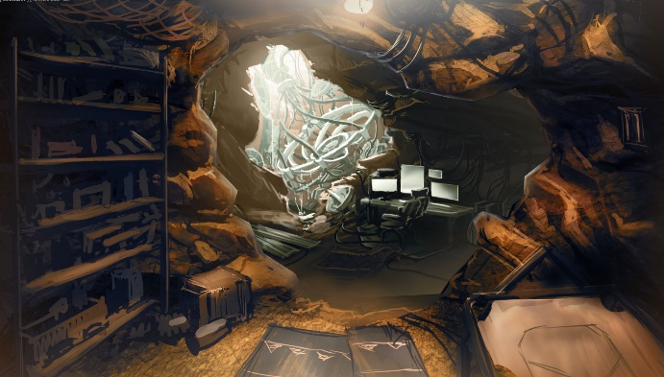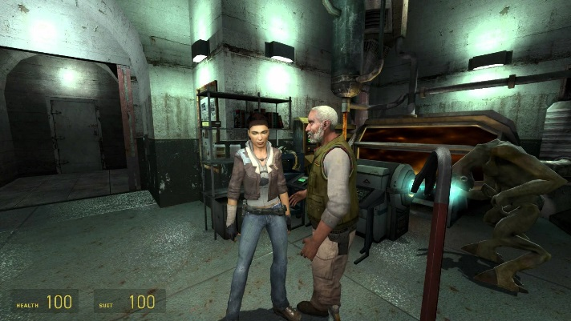

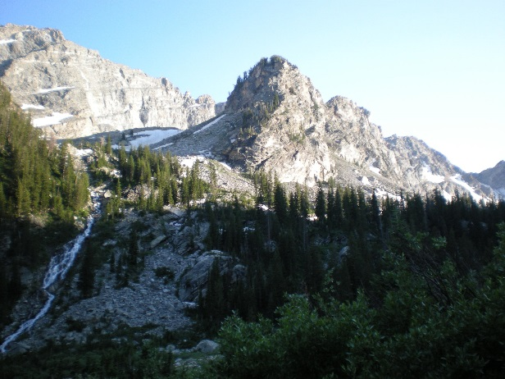

Figure 1: Concept art for a secret research lab [26]

Figure 2: In-game example of research hideout [25]

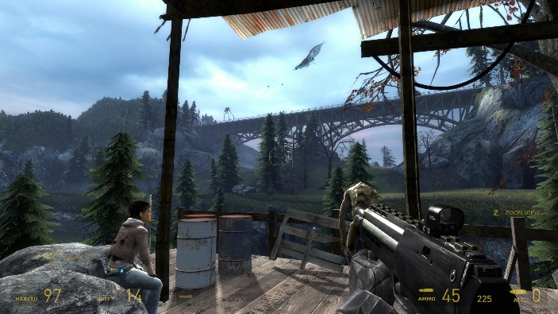

Figure 3: Countryside example (*Half-Life 2: Episode 2* screenshot) [27]

Figure 4: Mountains and Pinewood forest reference [28]

# Level Summary

## Campaign

### Context

“Ride the Shark” is a stand-alone level, taking place during the events of *Half-Life 2: Episode 2*. It is single-player and does not relate to the main campaign. The level starts with the usual FPS gameplay style of the *Half-Life* series, but quickly changes to a 3rd-person perspective flying shooter.

### Backstory

In “Ride the Shark”, Gordon Freeman is helping Dr. Kleiner and other Black Mesa’s scientists in the development process of a flying vehicle called Space-shark. However, the Combine uncovers their hideout and attacks them before they finish the technology. In order to prevent the destruction of the Research Facility, Freeman must use the underdeveloped airship to fight the units before they reach the lab, flying through the canyons and mountains.

### Aftermath

After successfully destroying the Combine enemies, Freeman goes back to the Research Facility to repair the Space-shark vehicle and continue its development process, as that technology might be a key element to win the war against the Combine once for all.

## Objective(s)

* Prevent the Combine from reaching the Research Facility:
  + Destroy their units (enemies type 1 and 2)
  + Avoid environmental obstacles (hazards)
  + Survive

## Overview Map

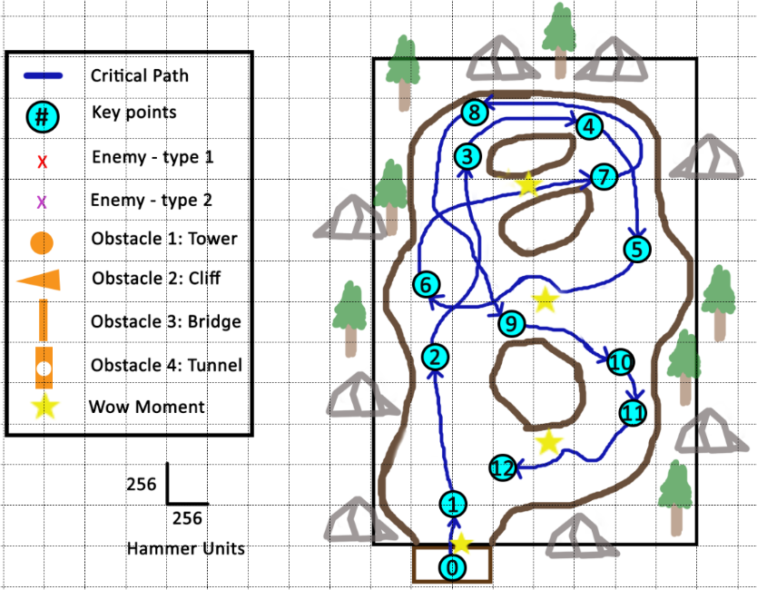

Figure 5: Overview Map (enemies not displayed for better map visualization)

## Level Flow

### Flow Summary

1. Players’ starting position: they explore the research facility, interacting with the environment. Then, they get into the vehicle, starting the actual gameplay
2. Players fly around in open space, experimenting with the mechanics
3. Players encounter some obstacles, which they have to avoid
4. Players face the first wave of enemies (small group – type 1). There are no obstacles to avoid
5. Players fight another wave of type-1 enemies (large group). No obstacles to avoid
6. Players encounter a small group of enemies (type 1) with some obstacles to avoid. After that, they have to avoid a more challenging obstacle to progress (WOW Moment)
7. Players must avoid some obstacles, while facing a large number of type-1 enemies. Then, they have to get into a tunnel (shortcut to the next area which is under attack – WOW Moment)
8. Players encounter the first wave of the second enemy type (type 2). There are no obstacles to avoid
9. Players fight against a wave of few enemies (both types 1 and 2), with no obstacles to avoid
10. Players face a similar wave (small number of type-1 and type-2 enemies), but with some obstacles on their way
11. After flying below the transitioning obstacle again, players encounter a group of enemies (numerous type-1 and a few type-2). They must also avoid some other obstacles
12. Players get into the most dangerous area, with numerous enemies of both types and more challenging obstacles (WOW Moment)
13. After going through a small tunnel, players fly to the initial open area, where they successfully conclude the level

Level Progression Chart

Figure 6: Level Progression Chart

Detailed Design

# Level Details

## Gameplay Area Breakdown Map

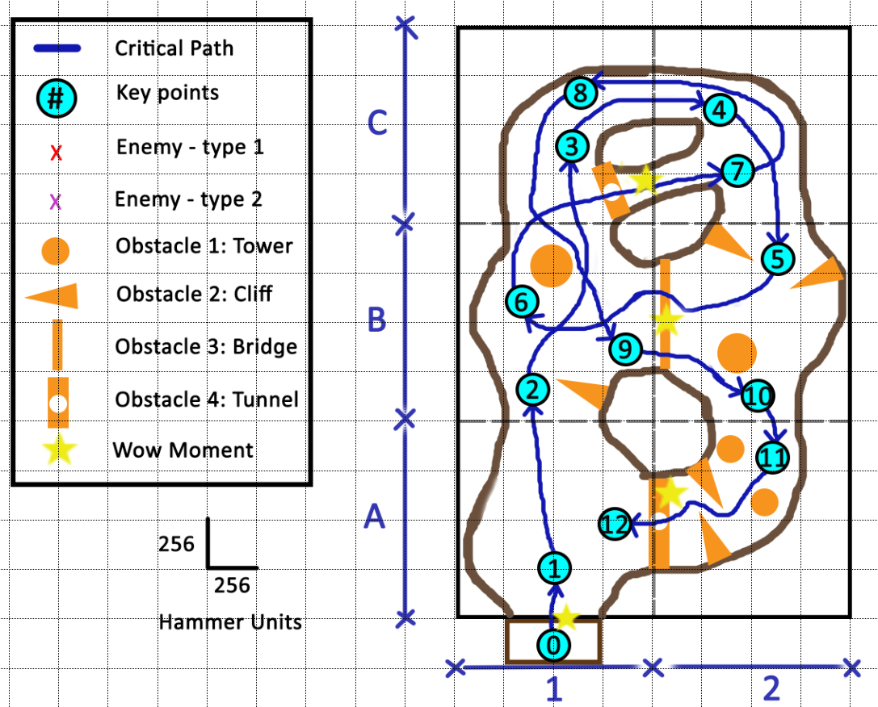

Figure 7: Area Breakdown Map (enemies not represented)

## Obstacle Types

|  |  |
| --- | --- |
| Figure 8: Obstacle 1 – Tower  Towers force the player to go around them, taking either left or right. | Figure 9: Obstacle 2 – Cliff  Cliffs force the player to either take an upper route or go around them. |
| Figure 10: Obstacle 3 – Bridge  Bridges force the player to go below them, around their supporting pillars. | Figure 11: Obstacle 4 – Tunnel  Tunnels force the player to take a specific route (inside the tunnel), blocking all the way around it. |

## Detailed Walkthrough

## Area 0: Research Facility

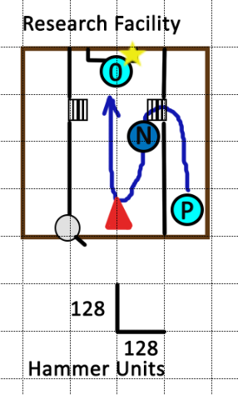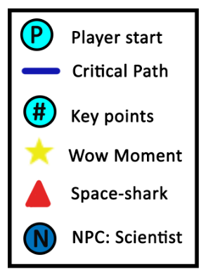

Figure 12: Area 0 Detail Map with Keys

### Initial Loadout

* Players start the game only with Gordon Freeman’s suit and the crowbar. They do not get any weapons, or any other equipment/item throughout the level despite the vehicle itself

### Gameplay/Story

Players start the game at **P** (figure 8), inside Black Mesa’s Research Facility. They explore the area, walk downstairs and talk to Dr. Kleiner (**NPC** – figure 8), who guides them to Space-shark. The scientist explains that, although the vehicle technology is still in development, their surroundings are under attack by the Combine units. Therefore, there is no time and players need to protect the lab, using the Space-shark.

1. Players approach the airship and mount it. The facility’s gates open up and they fly to combat (WOW Moment).

### Text and Dialog

#### Objective Text

* Space-shark controlling instructions:
  + “W: Move Up”
  + “S: Move Down”
  + “A: Move Left”
  + “D: Move Right”
  + “Left Mouse-Button: Submachine Gun shot”
  + “Right Mouse-Button: Missile shot”

#### Dialog/Script

* Dr. Kleiner: “Gordon Freeman, there is no time! We better hurry! The Combine units are approaching this area. I know that the flying vehicle technology is still in development stage but it’s our only chance against them. Please, use it and eliminate the arriving Combines. I will open the gates for you. Be careful!”

### Visual References

#### Theme

This area’s theme is old sci-fi research lab (research hideout).

#### Characters/Vehicles Introduced

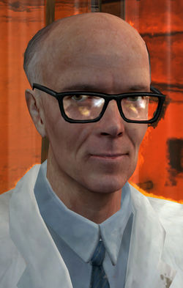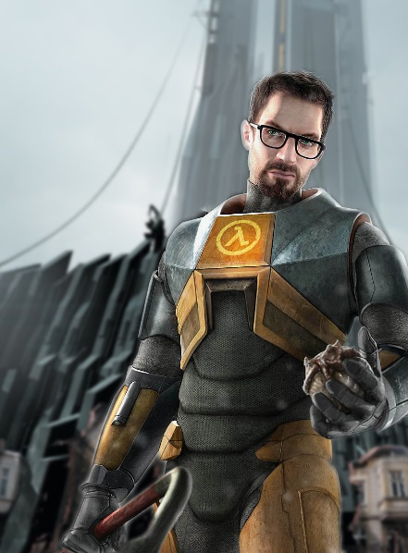

Figure 13: Main Character Example (Gordon Freeman) [1]

Figure 14: Dr. Kleiner [5]

#### 

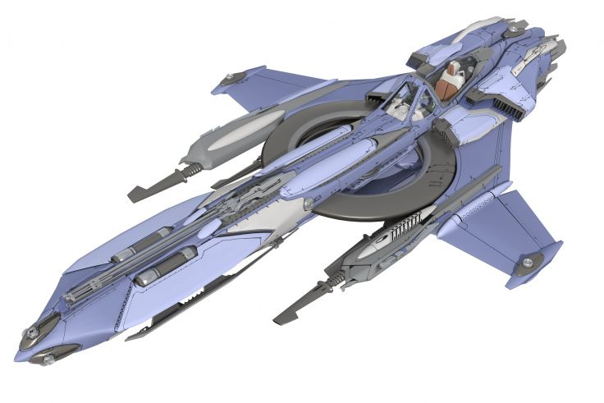

Figure 15: Another example of ship used as reference for the Space-shark [4]

Figure 16: Example of Shark-shaped ship (reference for the Space-shark vehicle) [3]

#### Environment References

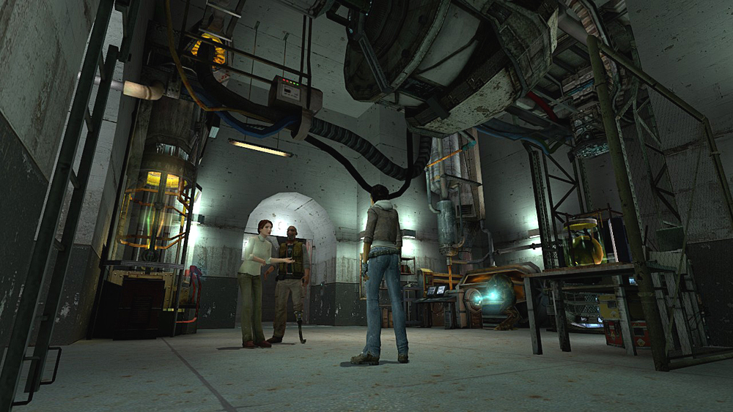

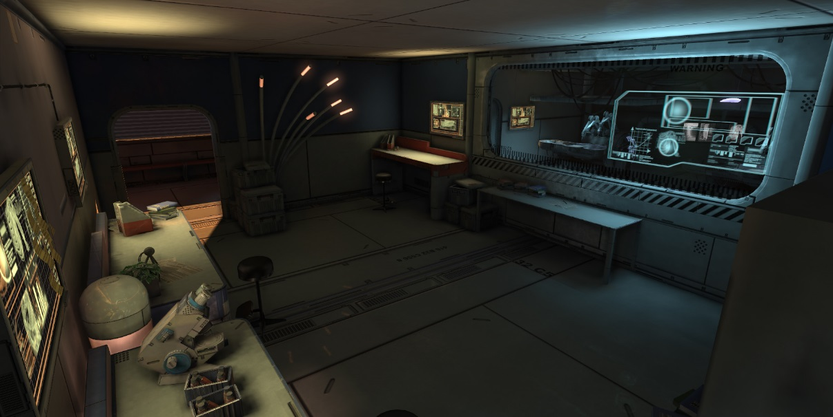

Figure 17: Old sci-fi lab (architecture and lighting examples) [6]

Figure 18: Example of Black Mesa’s hideout – reference for models, architecture and mood [2]

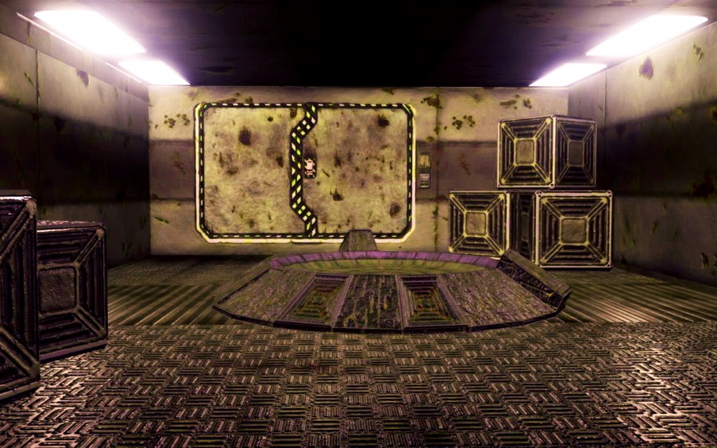

Figure 19: Texture example for old sci-fi setting [7]

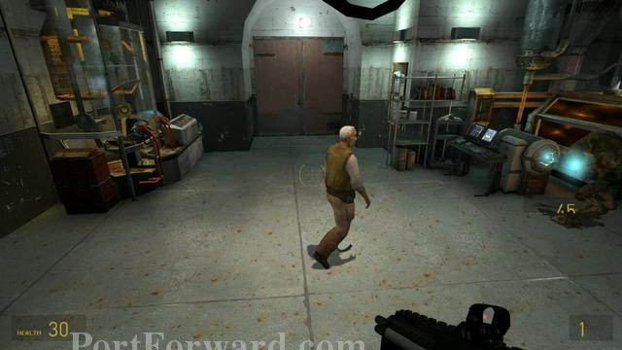

Figure 20: In-game reference for Black-Mesa research facilities (models and lighting) [8]

### Perspective Shots

N/A.

## Area 1: Warm Up

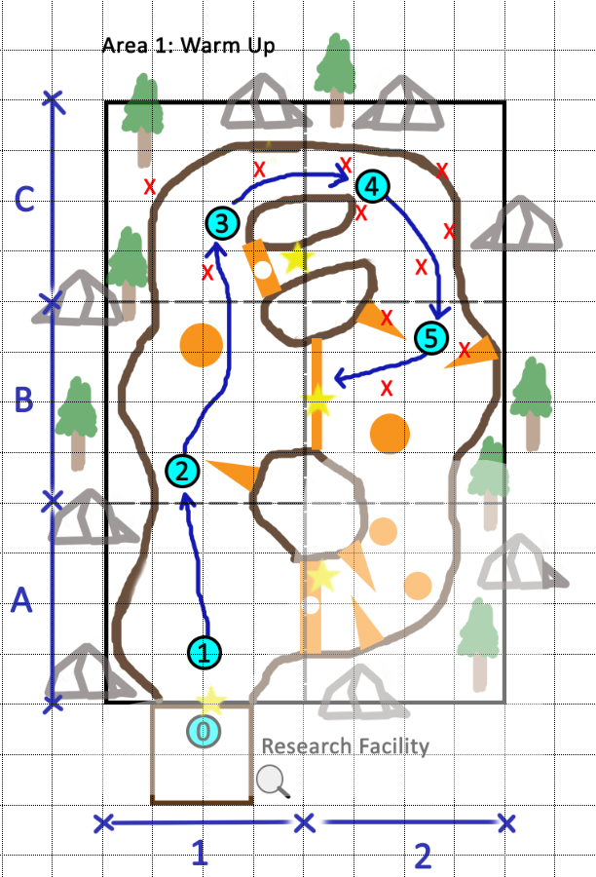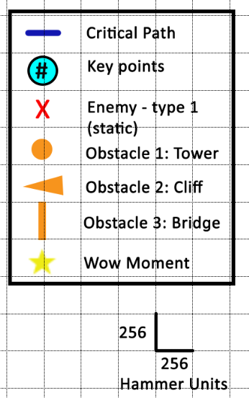

Figure 21: Area 1 Detail Map with Keys

### Gameplay/Story

1. (Quadrant A-1) Players explore the open space, looking for Combine units. They do not find anything – opportunity to experiment with the mechanics and get used to them
2. (Quadrant B-1) As they progress, players must avoid natural/environmental obstacles (cliff and tower). There are no enemies in this quadrant
3. (Quadrant C-1) Players engage the first group of Combine units: enemies type 1 (static turrets). Those turrets do not move. There are two down below the players (ground) and another one on the left in the mountains.
4. (Quadrant C-2) Going between the narrow canyons, players encounter a similar group of enemies, but more numerous this time. The type-1 enemies can shoot the players directly with their turrets.
5. (Quadrant B-2) As the area widens up, players have more space to maneuver in between cliffs and towers (obstacles), however there is a small set of type-1 enemies waiting for them. After that, they must go below the bridge (train rail – obstacle), avoiding damage, in order to go back to the quadrant B-1 which is now under attack.

### Text and Dialog

#### Objective Text

* “Protect Black-Mesa’s Research Facility”

#### Dialog

There is no dialog here.

### Visual References

#### Theme

This area’s visual themes are:

* Rocky mountains (cliffs, canyons)
* Pine woods
* Riverbed (following the player’s path)
* Train track (rails)

#### Characters/Vehicles Introduced

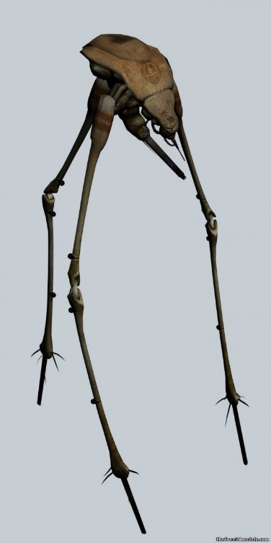

Figure 22: Reference for the type-1 enemy (turrets similar to the striders) [9]

### Environment References

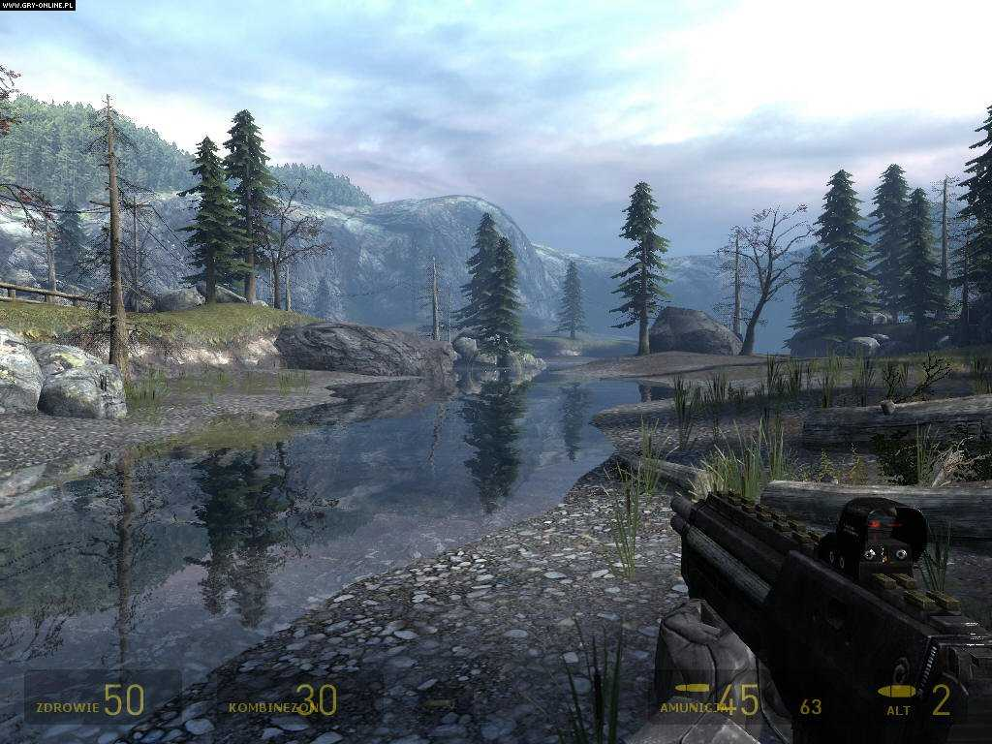

Figure 23: In-game reference for setting, texture and models – riverbed [10]

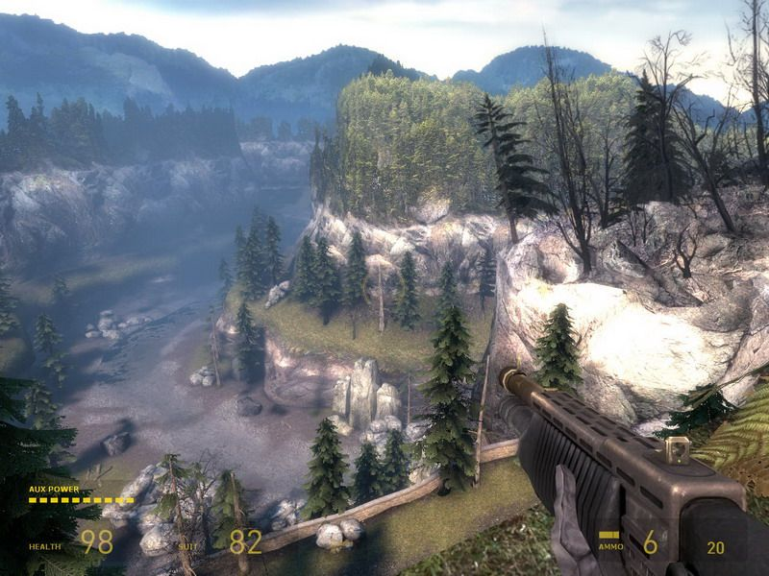

Figure 24: In-game reference for setting, texture and models – canyons and mountains [11]

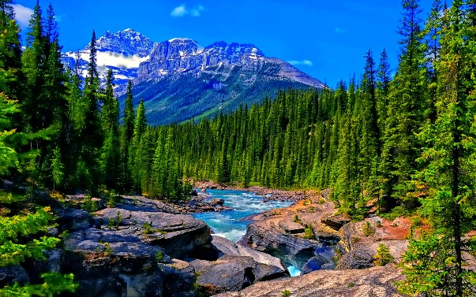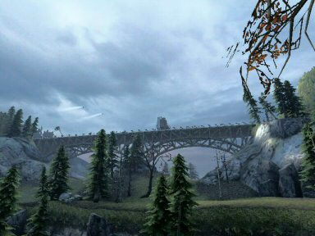

Figure 25: Reference for riverbed along the mountains [13]

Figure 26: In-game reference for models - train track/rails [12]

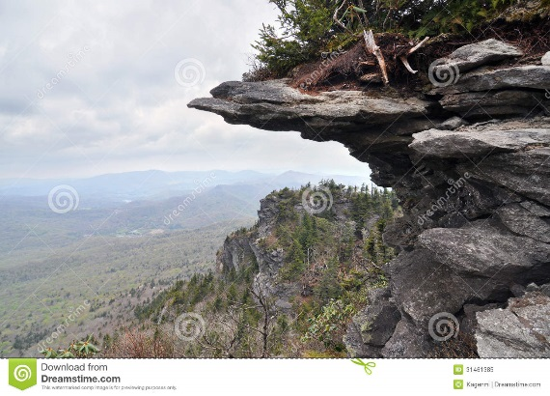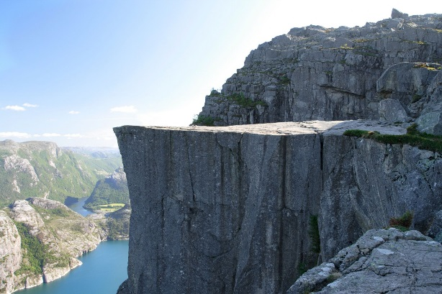

Figure 27: Another example of cliff [15]

Figure 28: Cliff example (game obstacle) [14]

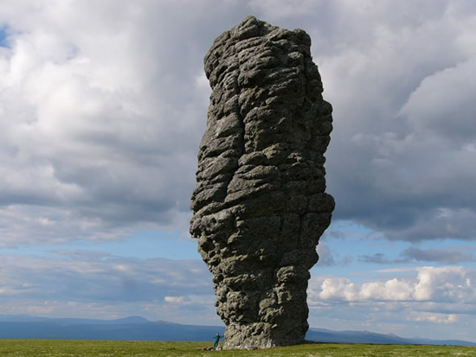

Figure 29: Example of rock tower (obstacle) [16]

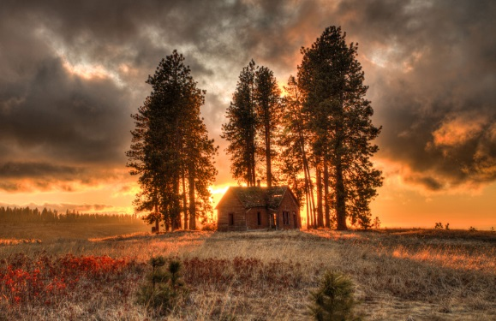

Figure 30: Lighting reference (sunset) [17]

### Perspective Shots

N/A.

## Area 2: Battle in the Mountains

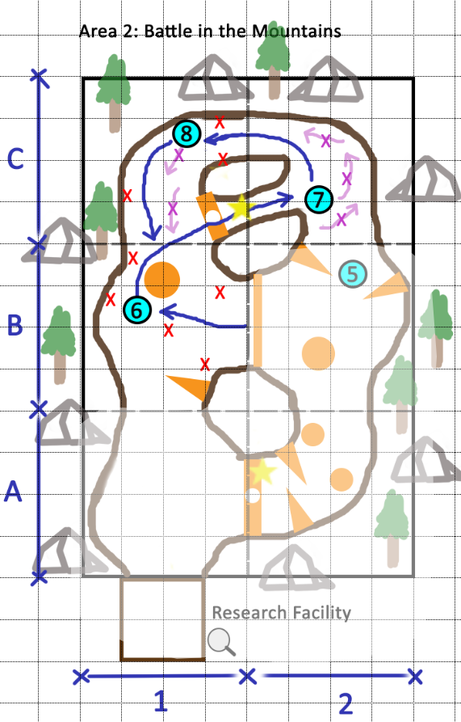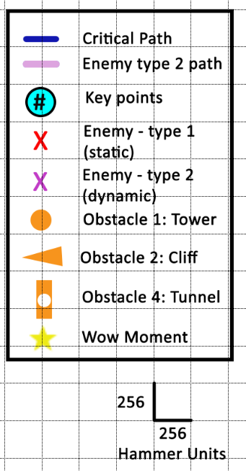

Figure 31: Area 2 Detail Map with Keys

### Gameplay/Story

1. (Quadrant B-1) After going under the bridge, players find the quadrant dominated by many type-1 enemies. They must destroy them, while avoiding cliffs and towers in this area
2. (Quadrant C-2) Then, players must take a shortcut to the other side of the area, going through a tunnel (obstacle – WOW Moment). In the other side, they face the second type of enemy (type 2 – dynamic). There are a few of them. These enemies fly around in the most different patterns and keep shooting the player while in movement. Players must be more careful
3. (Quadrant C-1) Going in the reverse direction than they did before, players keep flying around the area to kill the other Combine units. In this quadrant, they must destroy group of type-1 and type-2 enemies (these enemies were not in this area before players got into the tunnel). There are no obstacles.

### Text and Dialog

#### Objective Text

There is no objective text in this area.

#### Dialog

There is no dialog in this area.

### Visual References

#### Theme

The visual themes are the same as the previous area. However, this one has the tunnel obstacle (WOW Moment).

#### Characters/Vehicles Introduced

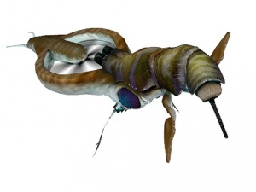

Figure 32: Reference for the enemy introduced by the area, type 2 (dynamic/flying) [18]

#### Environment References

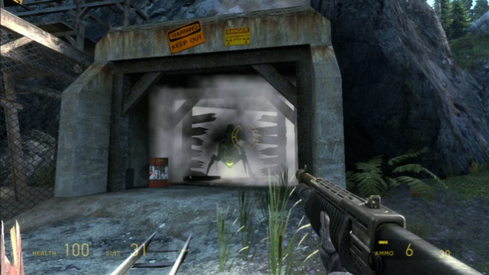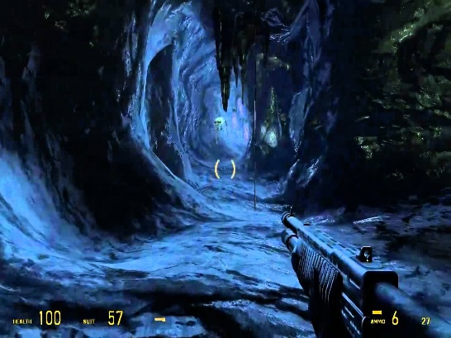

Figure 33: Another reference for the tunnel (different approach: train tracks) [20]

Figure 34: Architecture/shape reference for the tunnel [19]

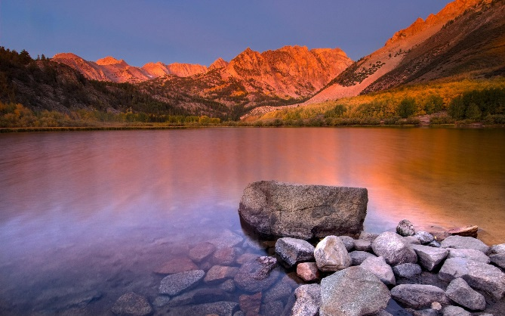

Figure 35: Sunset example for lighting and colors [21]

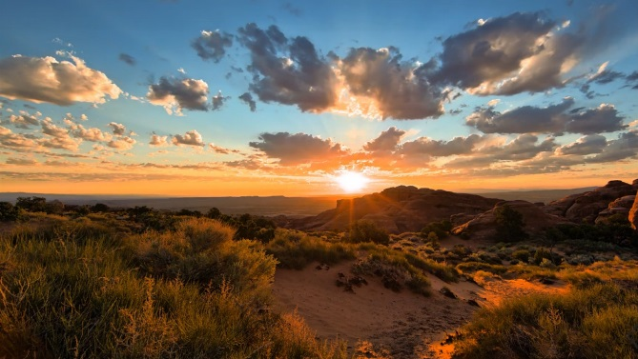

Figure 36: Similar color palette for sunset lighting [22]

#### Perspective Shots

N/A.

## Area 3: The Final Impulse

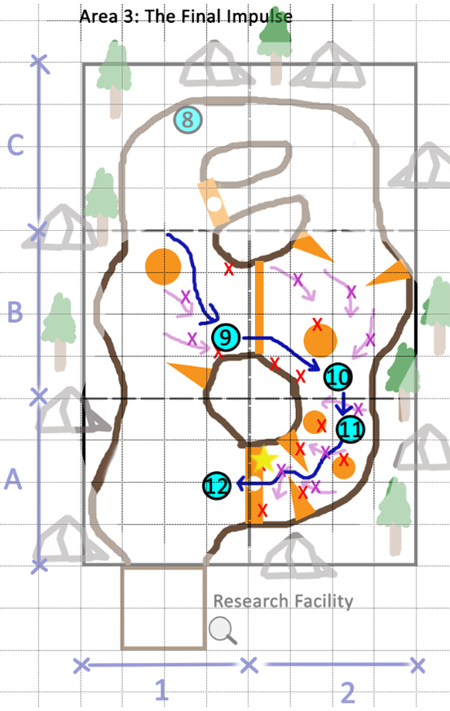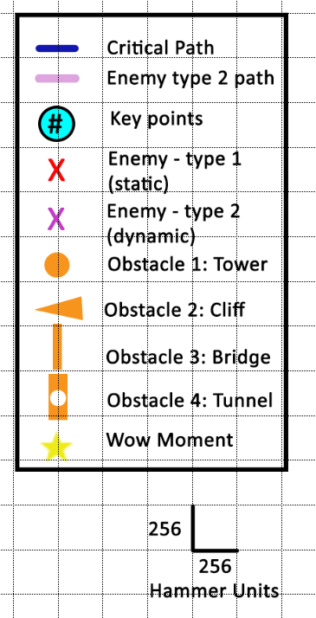

Figure 37: Area 3 Detail Map with Keys

### Gameplay/Story

1. (Quadrant B-1) Players have to fly among obstacles, while encountering a small group of enemies (type 1 and type 2). Then, they must go through the bridge again to reach the final part of the level
2. (Quadrant B-2) This quadrant has even more enemies of both types, but the obstacles are similar to the previous situation. Players must keep going to reach the last part of the map, where the Combine units are very close to the Research Facility
3. (Quadrant B-3) The most challenging part of the level – players must fly in a narrow canyon, facing many type-1 and type-2 enemies, while avoiding obstacles that are everywhere (cliffs and towers). Towards the end, there is a short mountain tunnel, which they have to fly through (WOW Moment) – Combine units intended to use that tunnel to attack the facility
4. (Quadrant A-1) Players get out of the tunnel alive, going back to the facility and successfully finishing the level (short cinematic – players do not have to fly all the way back)

### Text and Dialog

#### Objective Text

There is no objective text in this area, only Dr. Kleiner’s audio message (next session).

#### Dialog

* Dr. Kleiner: “Good job, Freeman! We knew you would save us. Now, come back to the lab, we need to fix the Space-shark before it falls apart!”

### Visual References

#### Theme

This area keeps the visual themes from the previous areas.

#### Characters/Vehicles Introduced

N/A.

#### Environment References

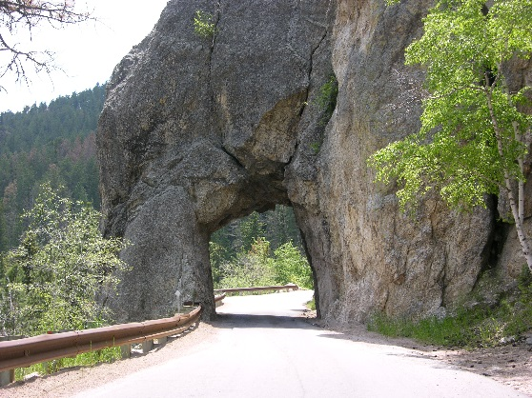

Figure 38: Moutain tunnel example [23]

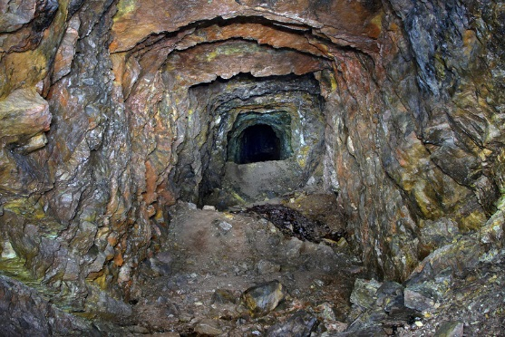

Figure 39: Another reference for the tunnel [24]

#### Perspective Shots

N/A.

# Critical Asset List

|  |  |  |  |  |
| --- | --- | --- | --- | --- |
| **Asset Name** | **Type** | **Use** | **Exists?** | **Link/Pic** |
| Space-shark | Dynamic_Mesh (vehicle) | Flying vehicle that player uses during the level | No | N/A |
| Dr. Kleiner | NPC_Actor | NPC that guides the player in the initial part of the level | Yes | http://img2.wikia.nocookie.net/__cb20090804094613/half-life/en/images/3/3b/Kleiner_model_ep2.jpg <http://img2.wikia.nocookie.net/__cb20090804094613/half-life/en/images/3/3b/Kleiner_model_ep2.jpg> |
| Enemy type 1 | NPC_Enemy | Turret-like enemy that attacks the player throughout the level | No | N/A |
| Enemy type 2 | NPC_Enemy | Flying Gunship that shows up in the second half of the level | Yes | http://i.ytimg.com/vi/sUrpgeHmrB0/hqdefault.jpg  <http://i.ytimg.com/vi/sUrpgeHmrB0/hqdefault.jpg> |
| Cliff | Physics_Mesh | Obstacle that forces players to go around it (above, below or left/right) | No | N/A |
| Tower | Physics_Mesh | Obstacle that forces players to go around it (left/right) | No | N/A |
| Bridge (Train Track) | Physics_Mesh | Obstacle that forces players to go necessarily below it | Yes | http://www.visualwalkthroughs.com/halflife2/episodetwo/whiteforest/8.jpg  <http://www.visualwalkthroughs.com/halflife2/episodetwo/whiteforest/8.jpg> |
| Tunnel | Physics_Mesh | Obstacle that blocks most of space, forcing players to go through a specific path | No | N/A |
| Space-shark HUD | Texture | HUD crosshair to indicate the vehicle direction for shooting | No | N/A |
|  |  |  |  |  |
|  |  |  |  |  |
|  |  |  |  |  |
|  |  |  |  |  |
|  |  |  |  |  |

Appendix

## Why is this fun?

This level is fun because it provides a new gameplay, which is completely different from anything seen in the Half-Life 2 series so far. By empowering players onboard of a flying vehicle, “Ride the Shark” provides a unique experience, where they can see the environment from a new perspective, with more freedom, while facing enemies from a different perspective.

## What makes this sequence interesting/memorable?

Following the previous answer, this sequence is interesting given the unique gameplay that it provides, along with memorable moments that demand a lot of player skill. When players fly through the tunnels or below the bridge, they feel satisfied and successful for overcoming such challenging obstacles.

## How will you communicate to the player what they need to know?

The level provides several different ways to communicate to the player what they need to know: NPC guidance (Dr. Kleiner’s initial dialog and audio message), text instructions on how to control the vehicle when the player mount it and a tutorial sequence followed by a reasonable learning curve.

## How can the player break it?

Players could break the level by:

* Not using the airship (they would not progress though)
* Exploring corners/edges of the level that triggers/scripting might not be completely covering, creating unexpected situations

# References

Cover Page:

<http://static1.gamespot.com/uploads/original/1514/15140406/2894976-4860409465-star-.jpg>

1. Figure 13 - <http://vignette3.wikia.nocookie.net/deadliestfiction/images/f/f7/Gordon-Freeman-holding-heart-gordon-freeman-25675652-865-1174.jpg/revision/latest?cb=20130418070004>
2. Figure 18 - <http://vignette4.wikia.nocookie.net/half-life/images/9/92/HalfLife2_BME_Eli's_lab.jpg/revision/latest?cb=20100212135728&path-prefix=en>
3. Figure 16 - <http://i.imgur.com/t50Og9f.jpg>
4. Figure 15 - <http://www.wallpaperup.com/167586/STAR_CITIZEN_sci-fi_spaceship_game_fw.html>
5. Figure 14 - <http://vignette2.wikia.nocookie.net/half-life/images/4/4e/Kleiner_bust.jpg/revision/latest/scale-to-width-down/250?cb=20130217235750&path-prefix=en>
6. Figure 17 - <http://www.torfrick.com/images/Lab5.jpg>
7. Figure 19 - <http://orig11.deviantart.net/02a2/f/2008/043/f/4/old_laboratory_by_elvin86.jpg>
8. Figure 20 - <http://portforward.com/games/walkthroughs/Half-Life-2/Half-Life-2-small-221.jpg>
9. Figure 22 - <http://tf3dm.com/imgd/l94179-strider-59303.jpg>
10. Figure 23 - <http://www.slzkq.com/halflife2episodetwo/gfx/gallery/large/Screenshots/2.jpg>
11. Figure 24 - <http://www.gamestar.hu/apix_collect/0802/half-life-2-episode-two/half-life-2-episode-two_20080223133834_6050_original.jpg>
12. Figure 12 - <http://www.shamusyoung.com/twentysidedtale/images/hl2ep2_freeman_pontifex1.jpg>
13. Figure 25 - <http://hdw.datawallpaper.com/nature/mountain-river-299782.jpg>
14. Figure 28 - <http://d1vmp8zzttzftq.cloudfront.net/wp-content/uploads/2010/04/preikestolen-famous-cliff-at-the-norwegian-mountains-1600x1066.jpg>
15. Figure 27 - <http://thumbs.dreamstime.com/z/mountainside-cliff-appalachian-landscape-horizontal-shelf-jutting-out-range-background-31461385.jpg>
16. Figure 28 - <http://cfile5.uf.tistory.com/original/147CC9104A1DC0F430F02F>
17. Figure 30 - <http://mariaehill.blogspot.com/2015_02_01_archive.html>
18. Figure 32 - <https://developer.valvesoftware.com/w/images/thumb/c/cf/Combine_gunship.jpg/300px-Combine_gunship.jpg>
19. Figure 34 - <http://i1.ytimg.com/vi/bn1vxd5LOtI/maxresdefault.jpg>
20. Figure 33 - <http://www.visualwalkthroughs.com/halflife2/episodetwo/pontifex/3.jpg>
21. Figure 35 - <http://www.wallpapersdb.org/wallpapers/nature/pink_sunset_lake_1920x1200.jpg>
22. Figure 36 - <http://7-themes.com/data_images/out/43/6918695-mountain-sunset-view.jpg>
23. Figure 38 - <https://upload.wikimedia.org/wikipedia/commons/7/78/One-lane_tunnel_to_Iron_Mountain_in_South_Dakota_Black_Hills.jpg>
24. Figure 39 - <http://www.steamphotos.com/Railroad-Photos/Abandoned-Railroad-Tunnels/WBH-Penobscot-Mountain-Tunnel/i-Cx9Tspg/3/L/IMG_6012-L.jpg>
25. Figure 2 - <http://i.ytimg.com/vi/2dUq_XdwyAg/maxresdefault.jpg>
26. Figure 1 - <http://i.imgur.com/V0m08gV.jpg>
27. Figure 3 - <http://i.imgur.com/raTPz.jpg>
28. Figure 4 - <https://tetontales.files.wordpress.com/2009/08/ellie-paintbrush.jpg>